**Setting Up a Docker Container with a Read-Only File System**

Ensuring the security and data integrity of Docker containers is critical in any robust DevOps environment. One effective measure is to run Docker containers with a read-only file system. This prevents any modifications to the container's file system during runtime, mitigating risks associated with unauthorized changes or accidental data corruption.

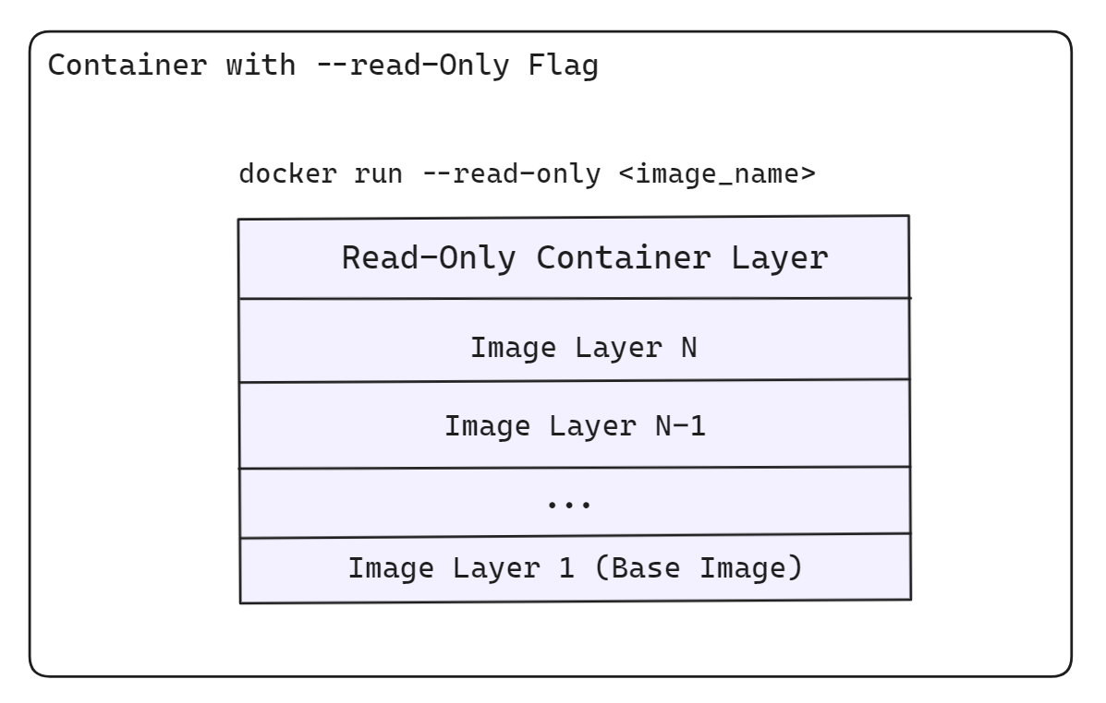

**Scenario Overview**

Imagine you are a DevOps engineer at a company that values security and data integrity. One of your tasks is to ensure that certain Docker containers run with a read-only file system to prevent any modifications to the container’s file system during runtime. You will set up a Docker container with a read-only file system and verify its behavior.

**Objectives**

* Set up a Docker container with a read-only file system.
* Verify that the container operates as expected and that the file system is indeed read-only.

**Required Steps**

**Step 1: Create a Docker Image**

**Create a Dockerfile: Create a file named Dockerfile and add the following content:**

FROM alpine:latest

# Create a directory and add a sample file

RUN mkdir /data && echo "This is a read-only test file" > /data/test.txt

# Set the working directory

WORKDIR /data

CMD ["sh"]

This Dockerfile creates a Docker image based on the Alpine Linux distribution, creates a directory /data and adds a sample file test.txt to it, and sets the working directory to /data.

**Build the Docker Image**: Open your terminal, navigate to the directory containing the Dockerfile, and run the following command:

docker build -t readonly-test .

**Step 2: Run the Docker Container with a Read-Only File System**

**Run the Docker Container: Use the --read-only flag to start the container with a read-only file system:**

docker run --rm -it --read-only readonly-test

**Verify the Read-Only File System**: Once inside the container, attempt to modify the file or create a new file:

# Try to modify the existing file

echo "Attempting to write to a read-only file system" >> /data/test.txt

# Try to create a new file

touch /data/newfile.txt

Both commands should fail, indicating that the file system is indeed read-only.

**Step 3: Verify Read-Only Behavior**

**Check for Errors:** The commands above should result in error messages similar to:

sh: can't create /data/test.txt: Read-only file system

touch: /data/newfile.txt: Read-only file system

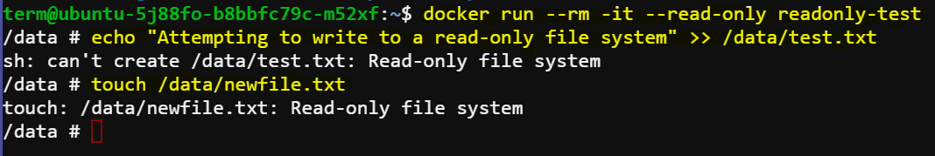

**Confirm File System Status**: You can further confirm the read-only status by inspecting the file system options:

docker inspect container_name | grep '"ReadonlyRootfs"'

Run this command in a new terminal so that the container state remains running. Replace container_name with the actual container name or ID.

This command should output true, indicating that the root file system is indeed read-only.

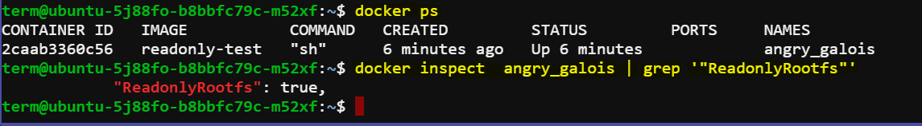

**Conclusion**

By following these steps, you have successfully set up and verified a Docker container with a read-only file system. This configuration helps enhance security and data integrity by preventing any modifications to the container's file system during runtime.